**Squander**

**Waste Management Application**

**USER MANUAL**

**Contents:**

1. **Getting Started……………………………………… 3-4**
2. **LogIn Screen………………………………………...... 5**
3. **SignUp Screen……………………………………… 6**
4. **Home Screen………………………………………… 7**
5. **Capturing or Selecting images…………………. 8**

5.1. Capture Image via camera…………………... **9**

5.2. Selecting From Photo Library………………. **11**

1. **Image Processing…………………………………. 12**
2. **Getting Results ……………………………………. 13**
3. **Recycling Location………………………………… 14**
4. **Location Details……………………………………. 15**
5. **Profile………………………………………………. 16**
6. **FAQ(Frequently Asked Questions)..................... 17**
7. **Request and Schedule……………………………. 18**
8. **Send Request………………………………………. 19**
9. **User Statistics……………………………………… 20**
10. **Contact Team………………………………………. 21**

**Getting Started:**

Welcome to the official user guide of Squander, an image-based waste classification application.

Before we begin, please ensure that the app is under testing so you download the app by sending a request to the email address “[**nagavkarrajat2852@gmail.com**](mailto:nagavkarrajat2852@gmail.com)” so that a link will be provided to you and you can proceed using the **“SQUANDER”** app.

After you download the app, follow this guide for instructions on how to recycle an item and plan for its proper disposal.

**Welcome to Squander**

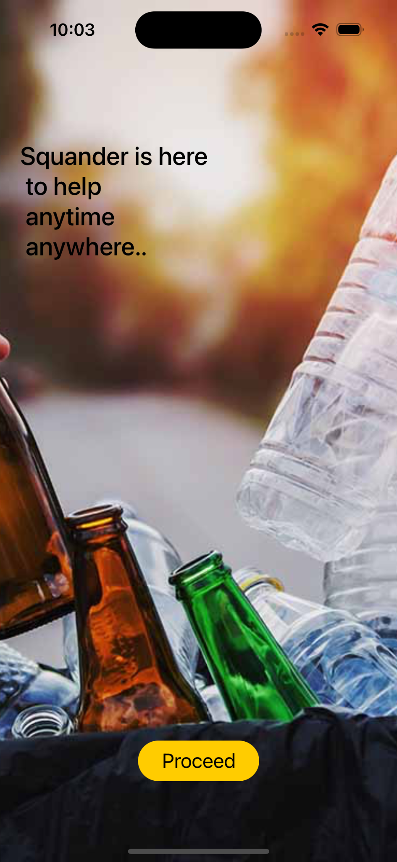The welcome screen will appear

after the app is launched, users can enjoy the experience of using the SQUANDER app by pressing the Proceed Button at the bottom.

**Login:**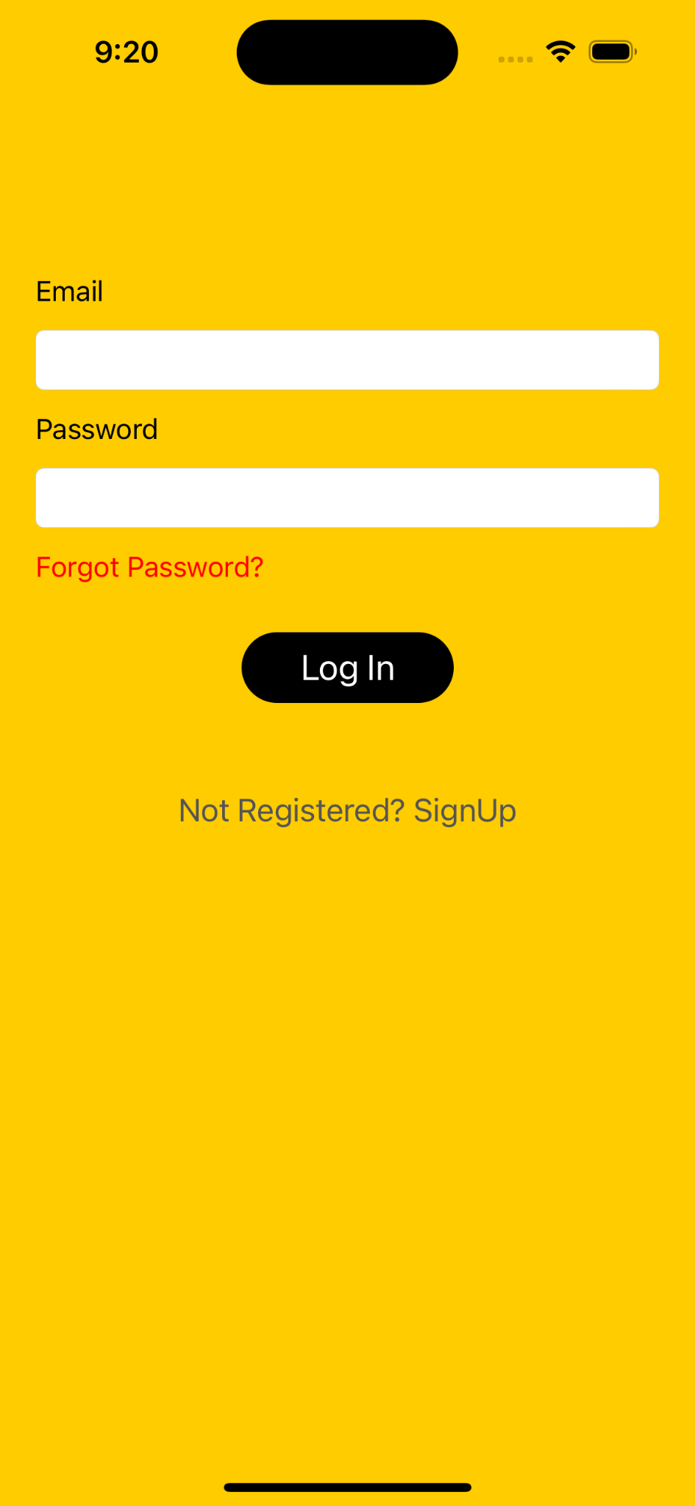

If a user is already registered on squander, can enter his email address and password to log into his account. There is Forget Password provisions to recover password.

**SignUp:**

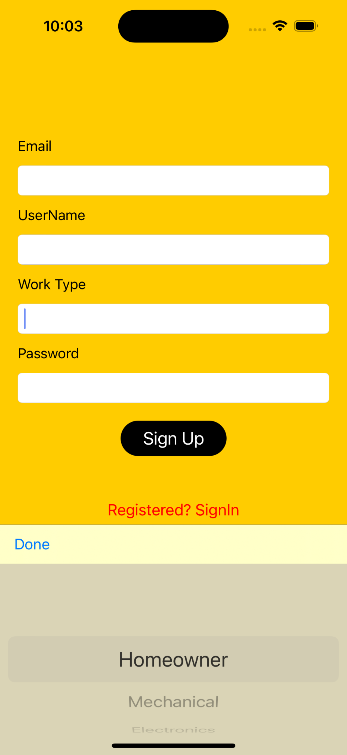

To SignUp as a new User, email

address, username, password,

work type which can be chosen as

homeowner, Mechanical, Electronics,

Construction and set password are to be entered.

After SignUp user is logged in and navigated to the home screen.

To navigate back to SignIn Screen

The SignIn link can be pressed.

**Home Screen:**

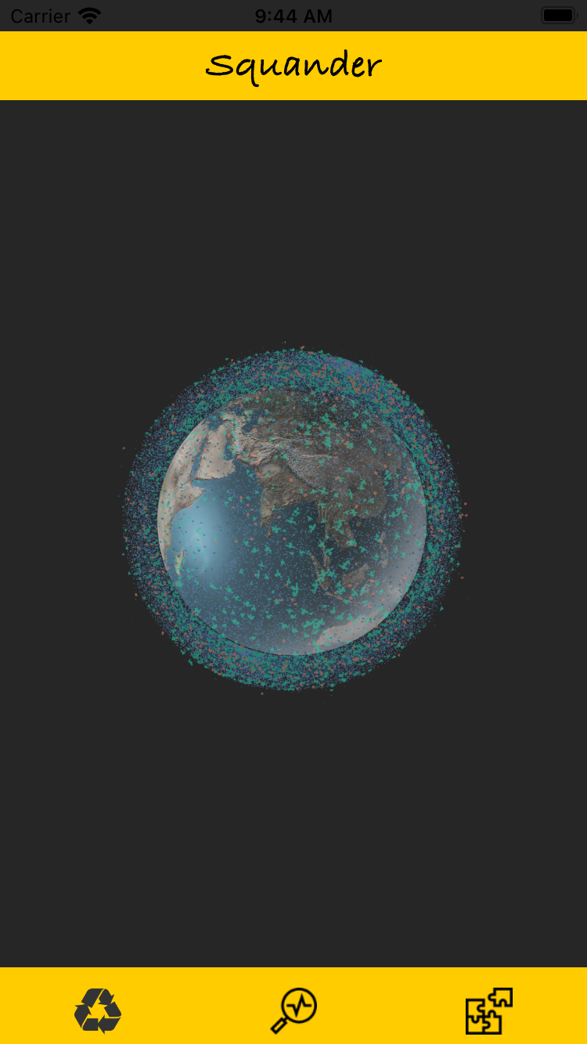

To know if a product can be recycled simply click on “Earth Image” in the center of the screen. This will prompt an alert so that you can select options to capture the image.

**Capturing or Selecting Image:**

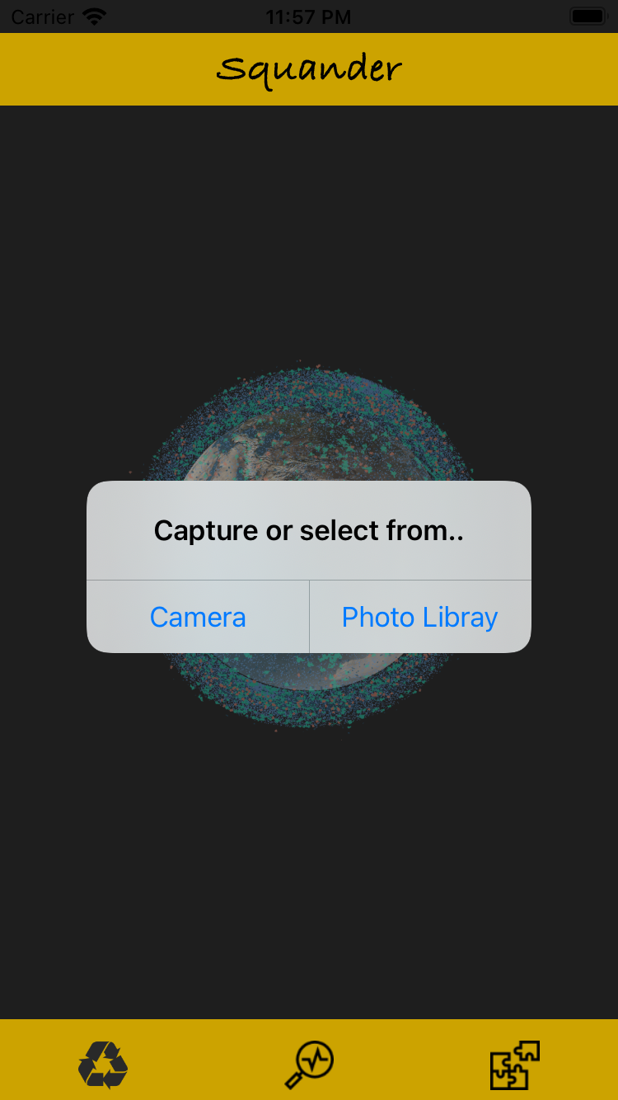

Once clicked on “Earth Image” an alert is displayed giving two options:

1. Capture Image via camera
2. Select the Image from the photo library.

Once clicked it will navigate you to the capture screen or photo library as per your action.

***If you want to dismiss this alert click outside of the alert.***

**1. Capturing Image via Camera:**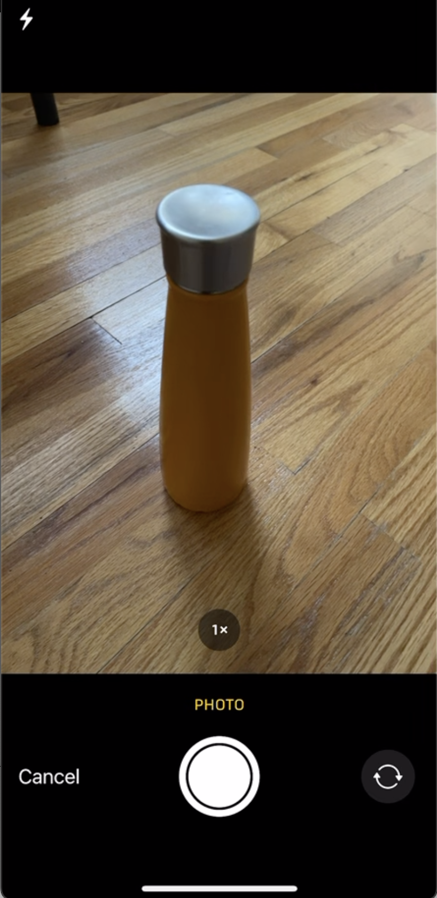

Selecting the option camera from the alert will navigate to the camera capture screen. Where they can click the capture button in the bottom center to Capture the image.

***Clicking on cancel will navigate to Home Screen***

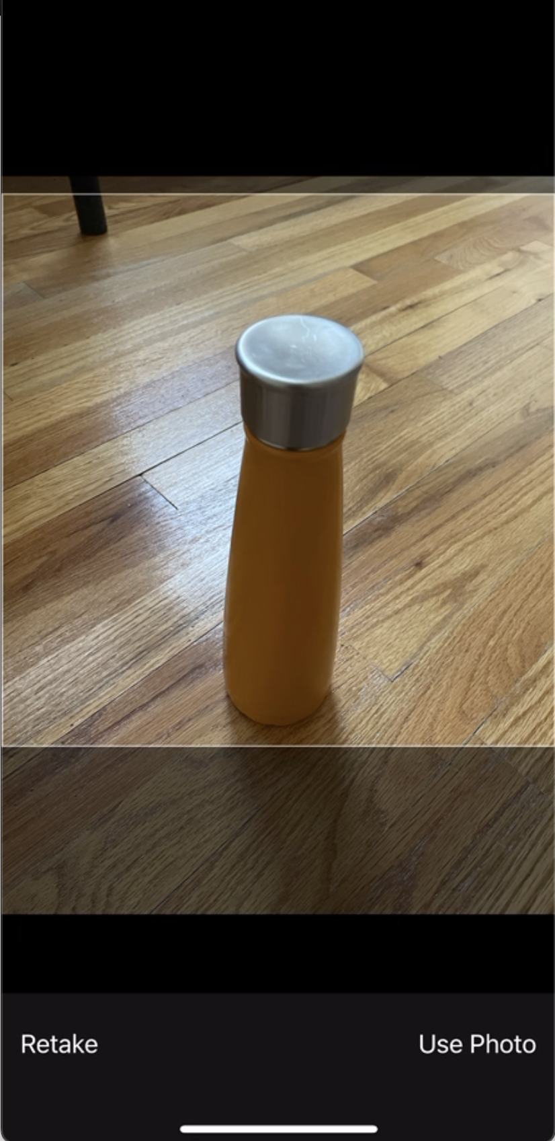

After capturing the photo, at the bottom bar, two options will be provided Whether to “Retake” or “Use photo”. Once clicked on “Use Photo” the image will be uploaded to a machine learning algorithm for the classification of recyclable waste from the image and you are navigated to the Processing screen.

***Clicking on retake will navigate to capture Screen***

**2. Selecting from Photo Library:**

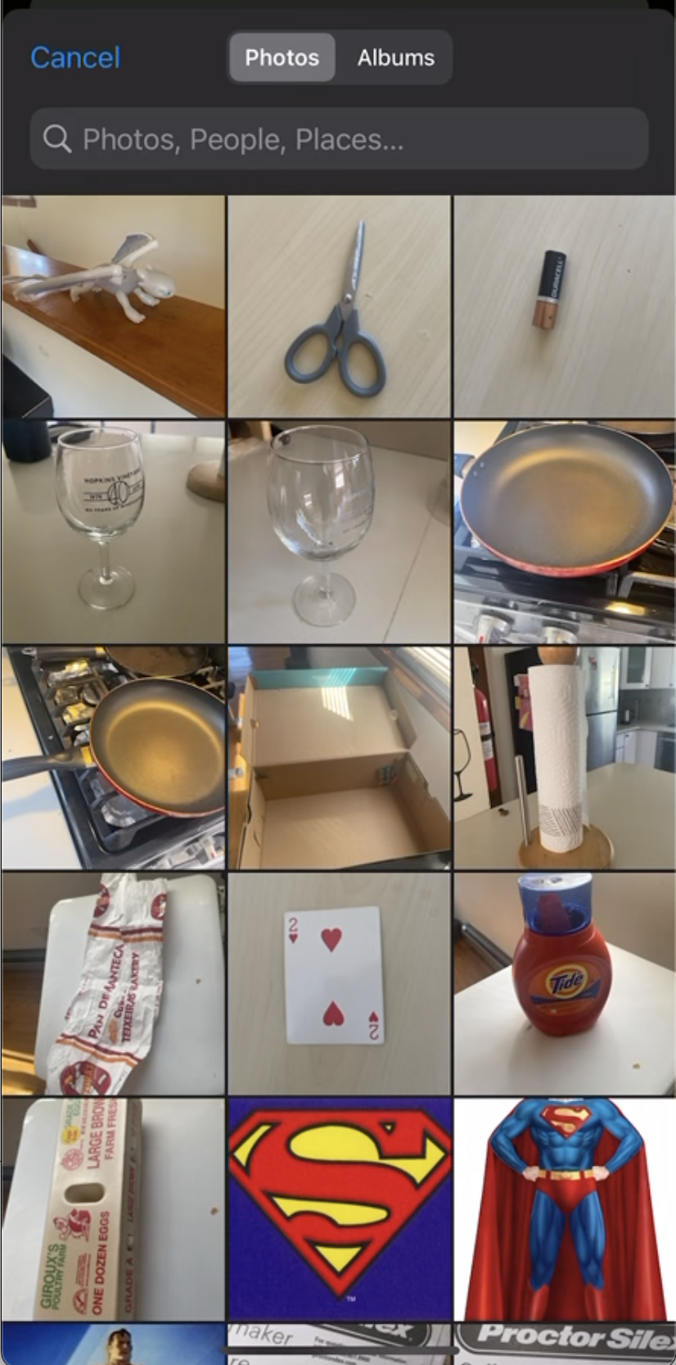

If you select option “Photo Library” from the alert, then you are navigated to a photo gallery where you can select images that are already captured and after which the image will be uploaded to a machine learning algorithm for classification of recyclable waste from the image and you are navigated to Processing screen.

**Image Processing:**

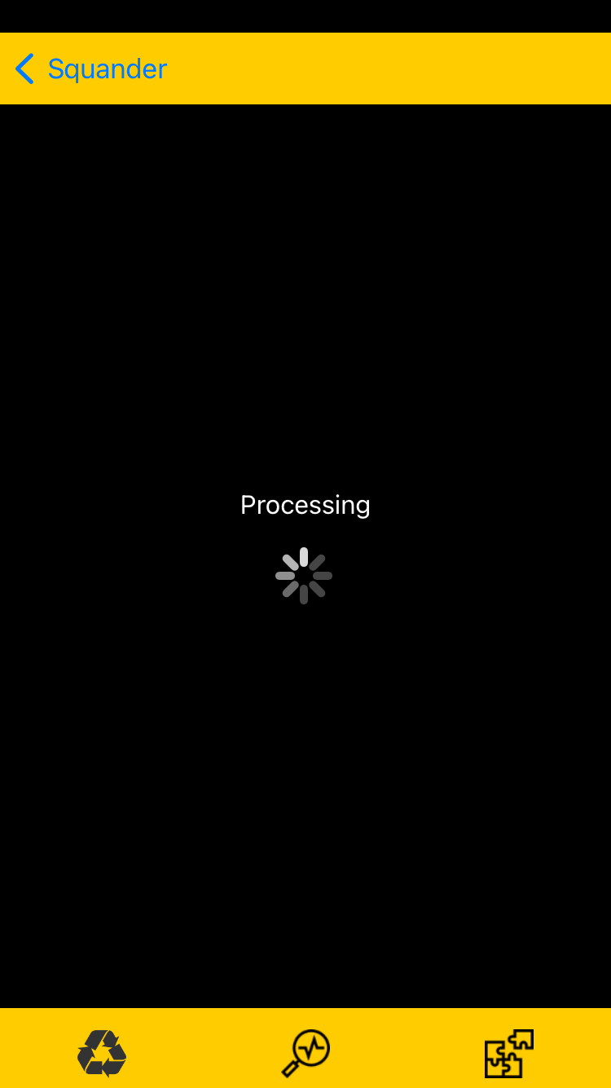

Once the image is captured or selected you will be navigated to the processing screen where the uploaded image is processed by Machine Learning algorithm.

***If you want to navigate back to the home screen, click on the arrow at the top left corner***

**Getting Results:**

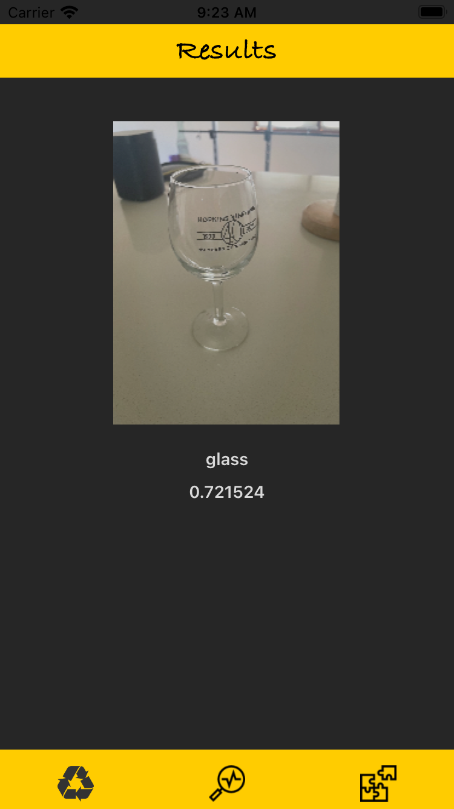

Now after processing the image by machine learning algorithm results screen is displayed giving information on recyclable items found in the image and their confidence value.

If a user must recycle can click on the recycle button to navigate to the recycle screen.

**Recycle location:**

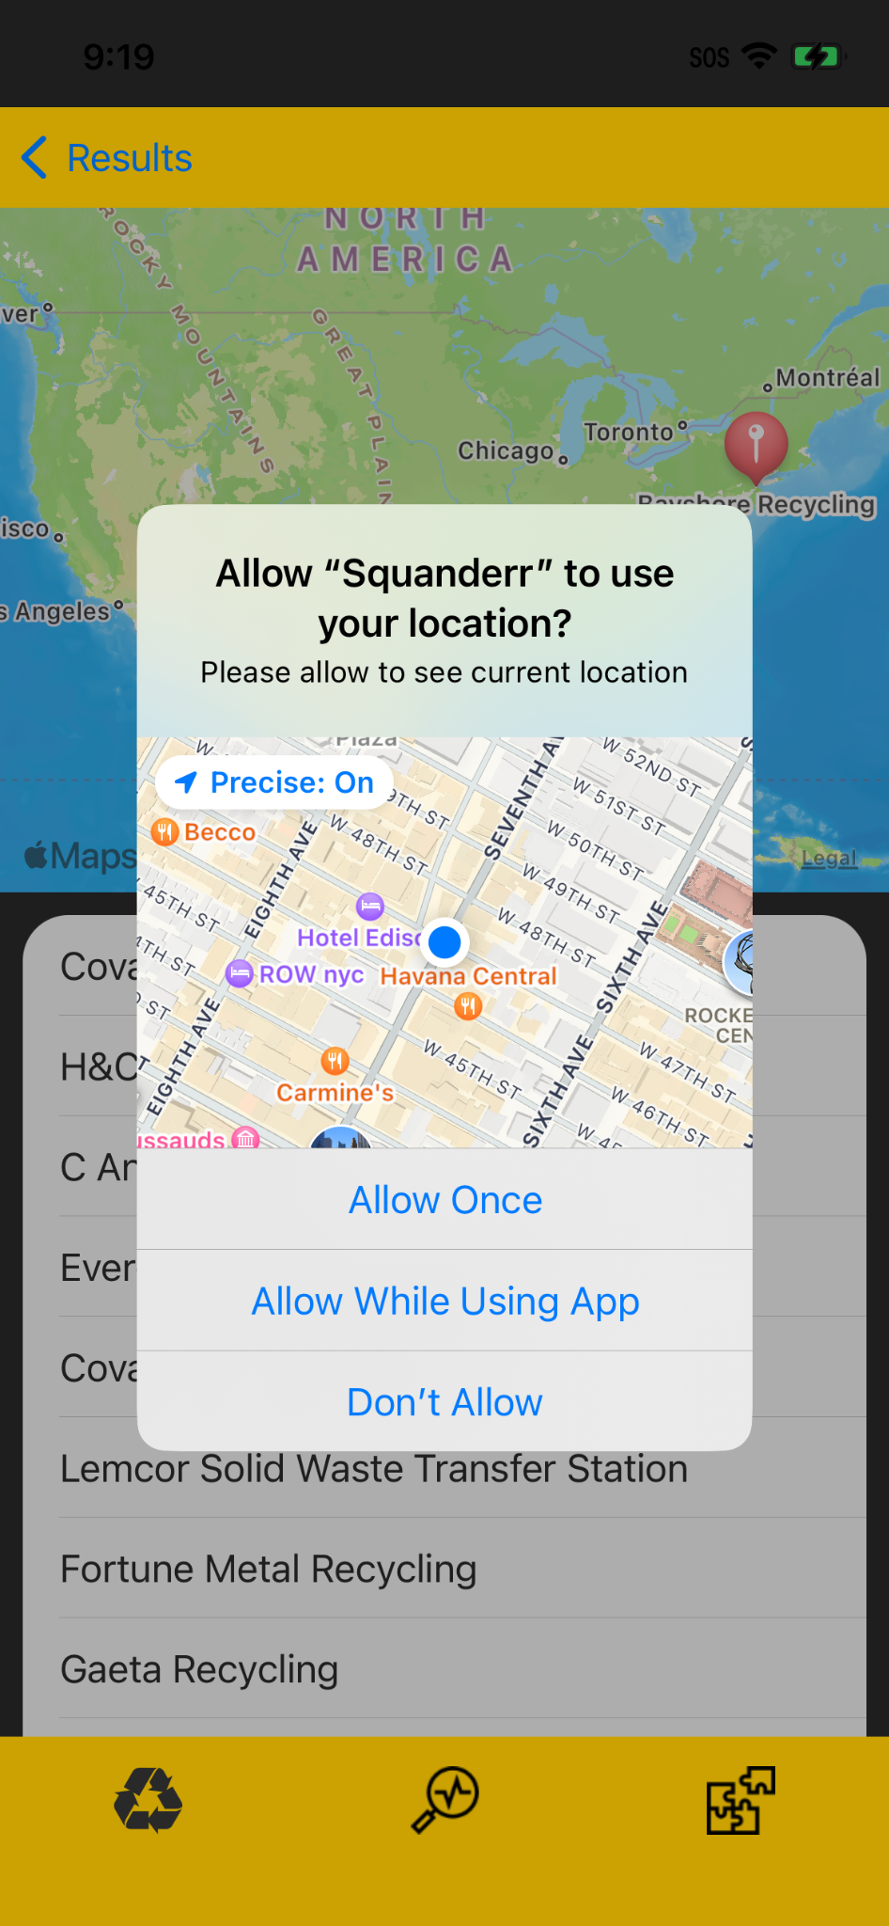

Users must allow permission to squander user locations.

Once permission is granted, it shows a map with the user’s current location and nearby recycling location with annotation on the map.

And below it, the user can find a recycling location list.

**Location Details:**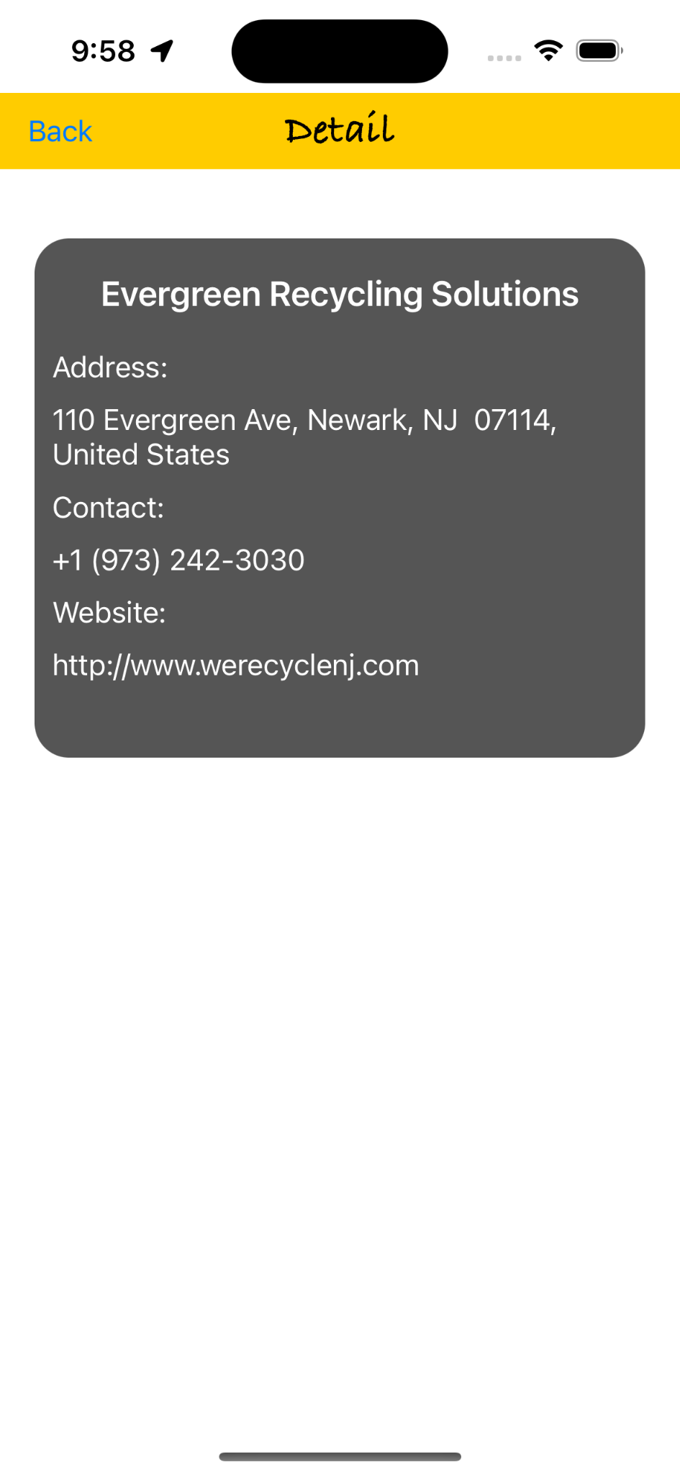

Details of the recycling location are seen on the detail screen where the name, address, contact, and website of the related recycling location are.

This data is useful for contacting recycling locations via phone numbers or reaching the website if a bulk number of items are to be recycled.

**Profile:**

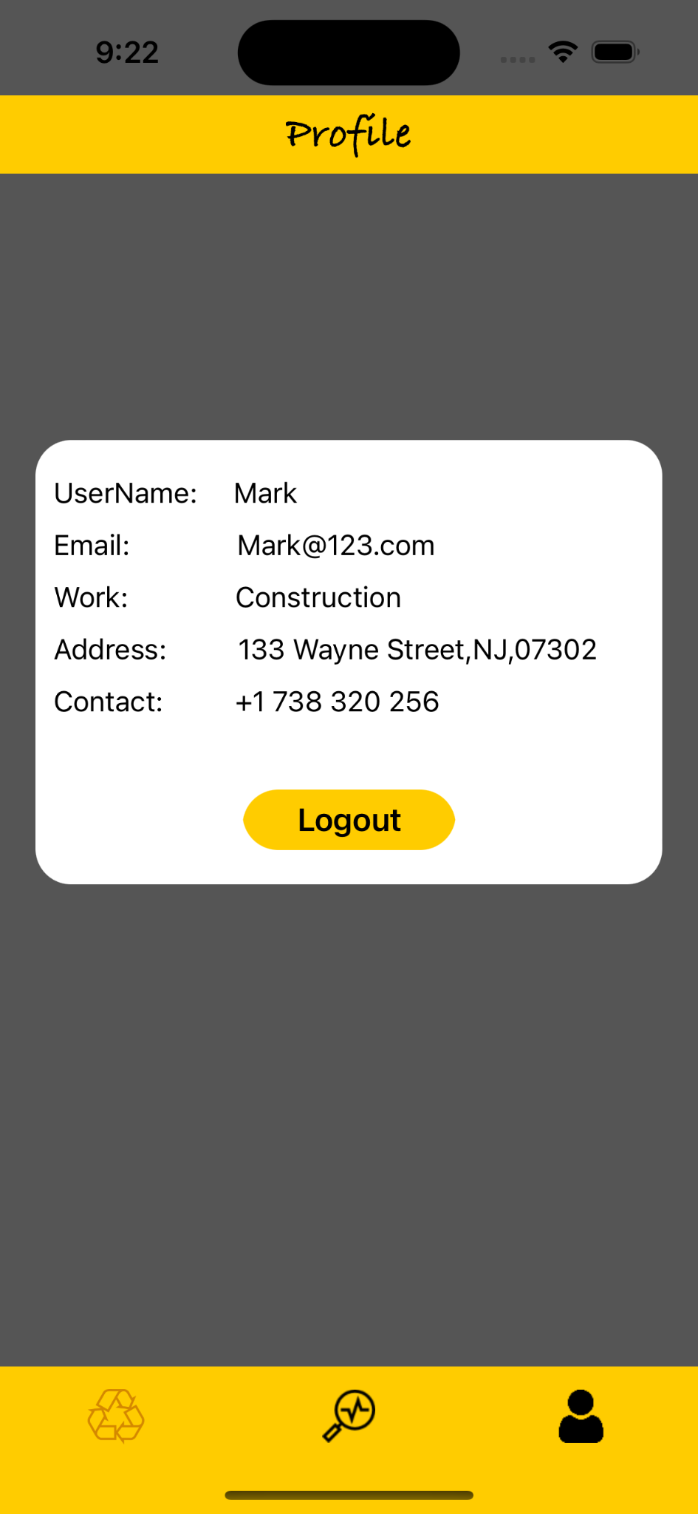

**Once logged in user can see**

**username, email, and work type**

**address and contact and can logout**

**by pressing the logout button.**

**FAQ(Frequently asked questions):**

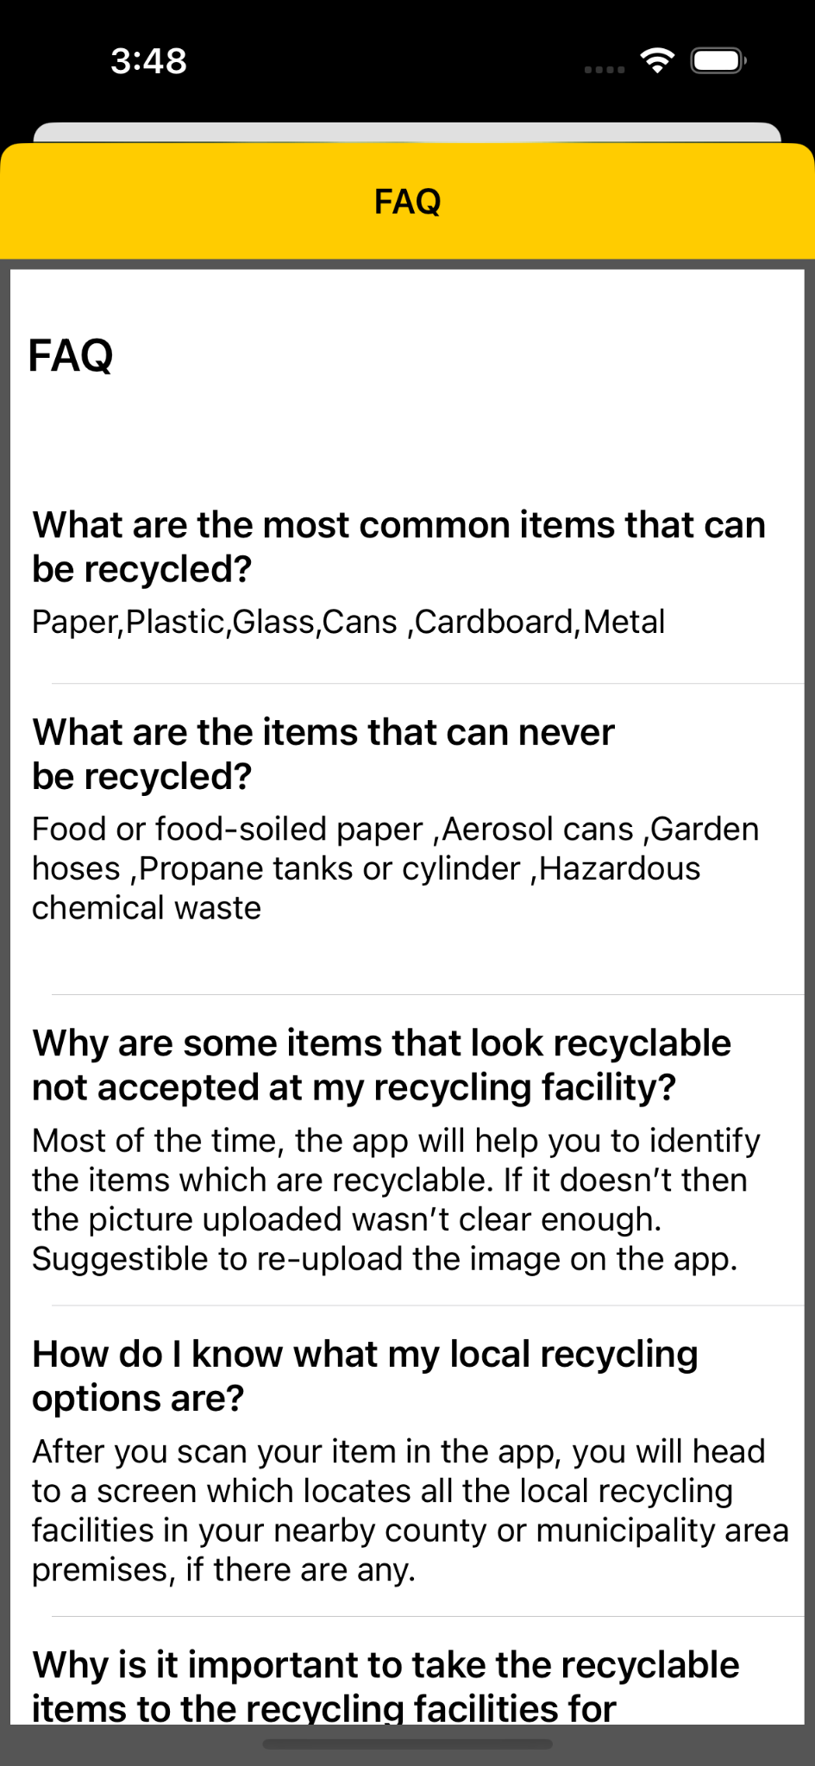

**A common query about the app**

**can be found at FAQ were**

**you will find answers to the questions like how the app is useful for them. What items they can recycle through the app and which cannot.**

**Request and Schedule:**

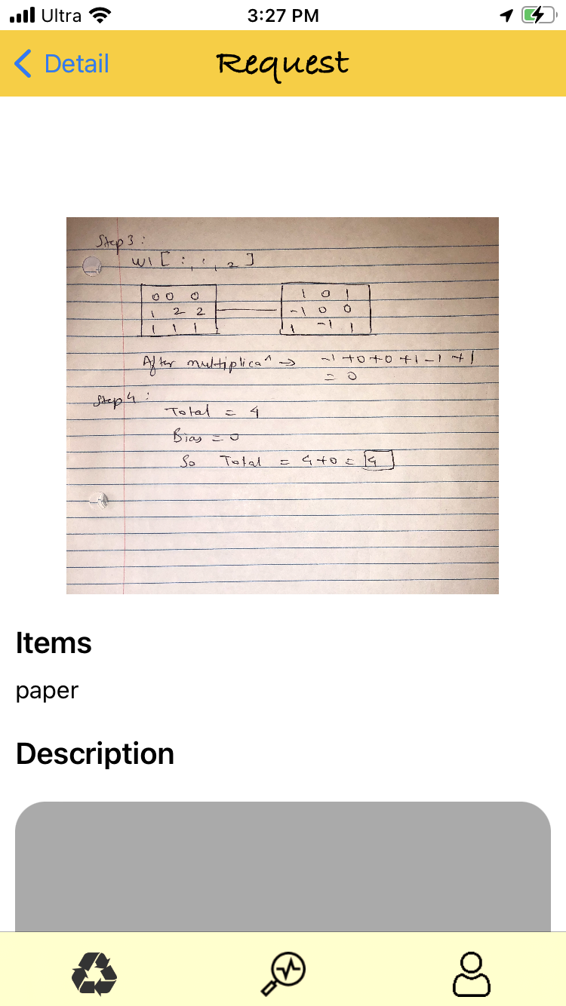

**If the user wants to contact the recycling location by sharing the image of the recyclable item and a short description of the products so that the recycling company can arrange for the vehicle to pick up waste according to the size of the items.**

**Send Request:**

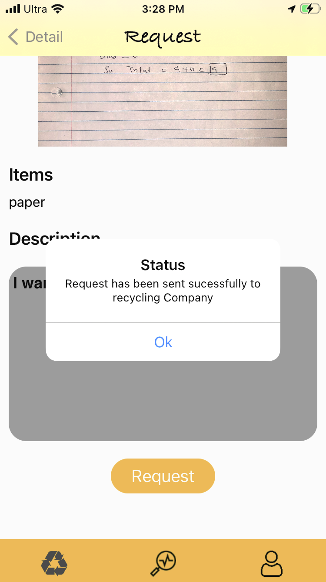

**After writing the description of items the user can press the request button so that request is sent to a recycling company.**

**User Statistics:**

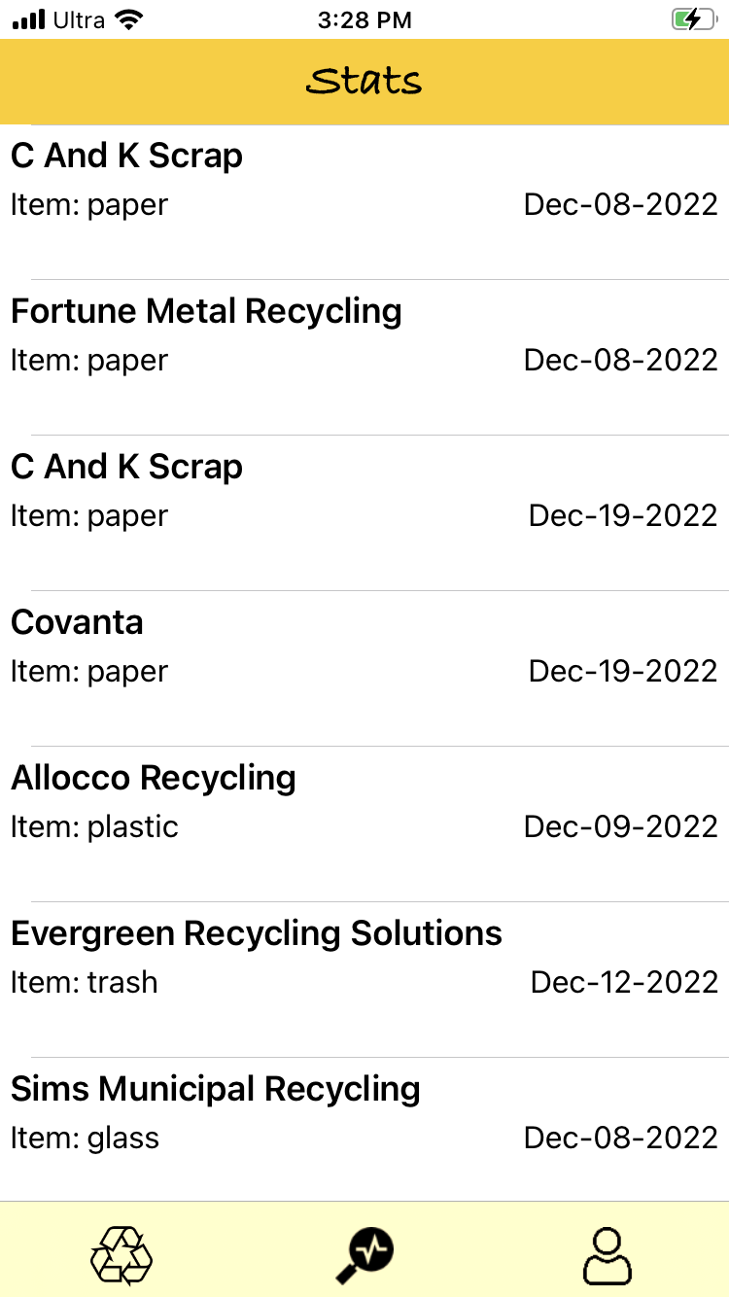

**Once the request is proceeded by the recycling company, statistics of the user are displayed, which tells about the whole usage of the app i.e number of recycling transactions done with a particular recycling company.**

**Contact Team:**

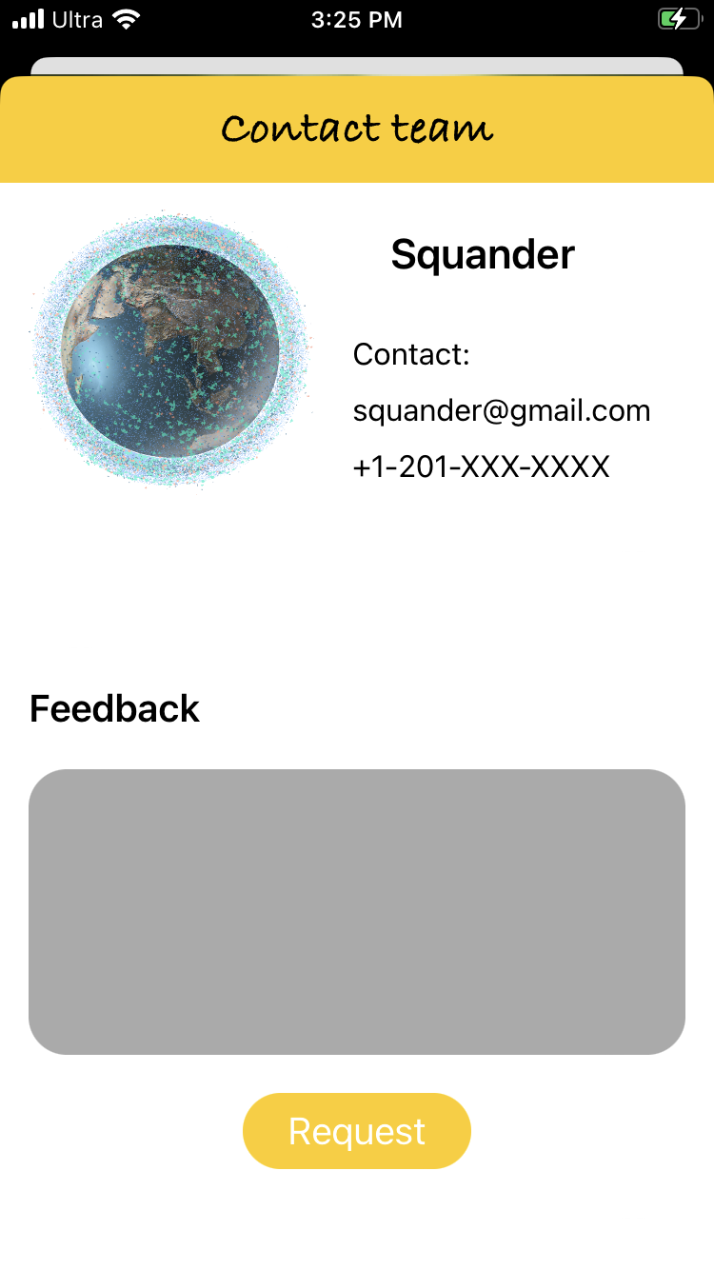

**If the user wants to contact the recycling**

**location can click the contact team link under the info screen.**

**Where the email address of the recycling location is mentioned, and the user can send feedback to Squander team about the usage of the app.**